

### DESIGN OF AUTOMATIC COCONUT DESHELLER MACHINE

**19AGP301 - MINI PROJECT III**

*Submitted by*

**HARSHINI S R 713521AG008**

**NANTHINI M B 713521AG018**

**PRIYADHARSHINI M R 713521AG021**

**PRIYA DHARSINI M 713521AG022**

*In partial fulfillment for the award of the degree of*

### BACHELOR OF ENGINEERING

***in***

**AGRICULTURE ENGINEERING**

## SNS COLLEGE OF TECHNOLOGY - COIMBATORE - 35

### An Autonomous Institution

**Accredited by NBA - AICTE and Accredited by NACC - UGC with ‘A++’ Grade approved by AICTE, New Delhi and Affiliated to Anna University, Chennai**

**COIMBATORE - 35**

## DECEMBER 2023

### BONAFIDE CERTIFICATE

Certified that this project report titled, **“DESIGN OF AUTOMATIC COCONUTDESHELLER MACHINE”** is the bonafide record of work done by the students,

**HARSHINI S R 713521AG008**

**NANTHINI M B 713521AG018 PRIYADHARSHINI M R 713521AG021**

**PRIYA DHARSINI M 713521AG022**

Who carried out Mini Project work under my supervision certified further that to the best of my knowledge, the work reported here in does not form part of any other project reports.

|  |  |
| --- | --- |
| **SIGNATURE**  **Ms. R. MUTHUMINAL PROJECT GUIDE**  **ASSISTANT PROFESSOR**  **Department Of Agricultural Engineering,**  **SNS College Of Technology,**  **Coimbatore - 641035.** | **SIGNATURE**  **Dr. B. SHRIDAR DEAN AGE/FT**  **Department Of Agricultural Engineering,**  **SNS College Of Technology, Coimbatore - 641035.** |

## 

Submitted for the mini project viva examination at,

(SNS COLLEGE OF TECHNOLOGY), held on ……………

**Internal Examiner I Internal Examiner II**

### ACKNOWLEDGEMENT

First and foremost, we would like to thank God Almighty for giving us the strength, knowledge, ability and opportunity to undertake this research study and to persevere and complete it satisfactorily. Without his blessings, this achievement would not have been possible.

The success of a work depends on team work and co-operation. We take this opportunity to express our gratitude and thanks to everyone who helped us in our project. We would like to thank the management for excellent facilities and the constant support provided by them to complete this project.

We wish to express our sincere regards and deep sense of gratitude to our principal

**Dr. CHENTHUR PANDIYAN** for the excellent facility and encouragement provided during the course of the study and project.

We are extremely grateful to The **Dr. B. SHRIDAR,** Dean, Department Of Agricultural Engineering for his constructive suggestion and encouragement during our project.

We take extreme gratitude to **Ms. HEMALATHA J**, Assistant Professor, Department of Agricultural Engineering, for his encouragement and cooperation in carrying out the mini project work.

We express our gratification to our project coordinator **Ms. R. Muthuminal, Assistant Professor/AGE** for her tremendous support and encouragement during our project. We are highly indebted to our project guide for motivating.

# TABLE OF CONTENTS

|  |  |  |
| --- | --- | --- |
| **CHAPTER NO** | **TITLE** | **PAGE NO** |
| **1** | **ABSTRACT** | **5** |
| **2** | **INTRODUCTION** | **9** |
| **3** | **MATERIAL AND**  **METHODS** | **13** |
| **4** | **SOLID WORKS** | **14** |
| **5** | **PROJECT DESCRIPTION** | **23** |
| **6** | **PROBLEM STATEMENT** | **30** |
| **7** | **CONCLUSION** | **31** |
| **8** | **LITRATURE REVIEW** | **39** |
| **9** | **RESULT** | **40** |
| **10** | **REFERENCE** | **41** |

## ABSTRACT

0ur project is about fabrication of coconut de-shelling machine. India, the world's second-largest coconut crop, lags behind in processing industry technology. To date, there have been numerous methods for peeling coconuts. The fundamental standard procedure is still being followed today. The labor-intensive traditional method used in India separates the shell and copra from split coconuts that have partially dried. A power-operated coconut deshelling machine was created in order to solve this issue. Coconuts can now be deshelling and shelled using a variety of techniques. Although these techniques are frequently used to remove coconut husk, there are a number of issues and restrictions with how these machines operate.1 The rate at which the coconut is deshelling is impacted by these issues. In order to get over these restrictions, enhance automation, and guarantee operator safety, a new design for a deshelling machine is constructed. With the use of a number of sharp instruments, two horizontal rollers are used in this deshelling to roll against one another and shred the coconut husk. Mature green coconuts and dry brown coconuts must be sheathed with force. Mature green coconuts demand higher shear force than dried coconuts. a deshelling machine for coconuts that has a belt-driven cutter. Analyses of the machine's performance tests reveal that the fruits were deshelled without any nuts breaking. Manual labor is used to load and unload the vehicle. This machine's construction employed only locally obtained, standard- specified materials. The machine is expected to cost six thousand, two hundred and fifty rupees (Rs.6250) to produce one unit. The device also removed our rural areas' reliance on the unreliable public electricity supply, which was a key barrier to the employment of other automated coconut deshelling equipment in such areas. To a greater extent, the issues and restrictions are removed by this machine.

When compared to the traditional coconut deshelling machine, this results in an increase in production rate. The primary goal of this device is to fully automate the deshelling and crown removal procedure, doing away with the need for a skilled operator to handle the coconut's deshelling. The technique is either manual or semiautomatic, despite the fact that coconut deshelling machines have already been demonstrated in the job [1,3,4] and in certain small-scale companies. Compared to the current method, a fully automated system that requires manual coconut loading and unloading will produce higher production. As a result, the majority of the current work is concentrated on developing an automated device for deshelling and crown removal. The conventional method used in India, for de-shelling the coconut labor intensive, unhygienic, time consuming and harmful to human body. Additionally, measurements of coconuts have been taken in a few other highly esteemed nations where significant coconut plantations are operated. The survey is used to define the coconut's maximum and minimum sizes. The equipment is made to work with coconuts of various sizes that are grown anywhere in the world. Additionally, a number of tests on mature and dry coconuts have been done to find the force needed to deshelling the coconut. The suggested experiments were carried out using a typical Universal Testing Machine. Using Solid Works software, a stiff machine is developed to handle the loads created during the deshelling process based on a variety of data collected, experiments, and machine design concepts. To overcome this problem, there is a need to automate the de-Shelling process. While automating the process the usefulness of the by-products is to carefully handled This innovative equipment employs a combination of cutting-edge technologies to ensure optimal performance. Its intricate design includes precision blades and automated mechanism, enhancing productivity while minimizing waste. The design of machine addresses the challenges associated with manual de-shelling, offering a cost - effective and time-saving solution for industries involved in coconut processing.

This abstract highlight the machine’s significance in improving efficiency and sustainability within the coconut industry. The paper is about fabrication of coconut de-shelling machine. The conventional method used in India, for de-shelling the coconut is labor intensive, unhygienic, time consuming and harmful to human body. To overcome this problem, there is a need to automate the de-shelling process. While automating the process the usefulness of the by-products is to be considered and carefully handled. A coconut de-shelling machine comprising of two cutters mounted on a same shaft with gear drive. Performances test analysis, show that the machine de-shelled the fruits without nut breakage as well as its average de-shelling efficiency is doubled and 300 coconuts can de-shell per hour. All materials used in the fabrication of this machine are of standard specification and locally sourced. The estimated cost of producing one unit of the machine is twenty-two thousand (Rs.22,000). The objective of project is to design and developed the coconut de- shelling machine and performance of machine which can remove maximum coconut shell at less time. The construction of machine will be simple in design so that it can be easily manufactured in small workshop. Also, the machinery will be of low cost so that an average farmer and small-scale vendor can afford to buy it. The automatic coconut peeling machine claims that: the power output is provided by a hydraulic transmission; the feeding disc, in conjunction with the lead screw and nut mechanism, functions as a feeding device; the upper and side cutters are matched; the coconut skins can be split open from the top, side face, and bottom end at the same time; peeling is quick, simple, and convenient; and processing automation is possible. ANSYS Workbench software is used to analyze the key parts of the machines, such as the main frame, drive shaft, and rollers, in order to determine the Maximum Principal Strain, Von Mises strain, and Maximum Principal Stress. The degree of freedom of the components during the machine's operating time has been considered and planned for during analysis.

Each element's specific loads have been computed and incorporated into the study. The study goes into great detail on the results obtained for the different load conditions. Based on these results, conclusions are made, which help to validate and enhance the design method.

Keywords : Copra, shell, coconut deshelling, Shear force.

## CHAPTER - 1

## INTRODUCTION

The main aim of this project is to reduce the human efforts and to increase the rate of de-shelling the coconut. This machine takes into consideration the dangers, hazards and risks involved in de- shelling the coconut which will be efficient, productive, environmentally friendly, less labors, easy to use and most importantly cost effective in production, maintenance and repair. The main purpose of coconut de- shelling machine is to eliminate the skilled operator involved in de- shelling the coconut and to completely automate the de- shelling and crown removing process. Although coconut de- shelling machines have already been demonstrated in the work and also in some small-scale industries, the process is either manual or semiautomatic. A completely automated machine with manual loading and unloading of coconuts will yield productivity higher than the existing process. Because of that, the current work is mainly focused on an automated machine for de- shelling and crown removing. Also, we can yield lot of useful and commercial products from coconut at various stages of its lifecycle. Today the agriculture is mechanized with the modern means. The agricultural activities like ploughing, sowing, harvesting nowadays involves many light weight to heavy machinery. Use of such machines is beneficial for both farmer and labour as it saves time of farmer and the tedious and cumbersome work is simplified to workers. It also enhances the productivity of farm. The agricultural activities are broadly classified into three groups. Pre-harvesting, harvesting and post-harvesting activities. All these three groups of activities are nowadays mechanized with machines. Pre harvesting operations are inserting seeds into farms, ploughing, irrigation etc. Harvesting means obtaining the fruits from the plants. Post harvesting is the operation which is required for the further processing of the fruits obtained from the plants.

Amongst different post harvesting operations, the coconut deshelling is regarded as a difficult task to perform. Coconut in India is grown on a large scale because of its numerous advantages and the atmosphere in coastal areas is favorable for its cultivation. Coconut gives coconut oil, coconut powder, husk is used to manufacture ropes, its medicinal properties etc. Hence its post harvesting is important. Many attempts have been made to make its post harvesting mechanized either manually or power operated. These attempts of mechanization have their own advantages and limitations.

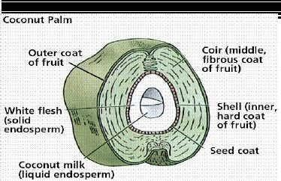

Coconut oil can be blended with diesel, straight in an adapted engine or turned into biodiesel. The fruit of the coconut (Cocos nucifera) is technically a large, dry drupe composed of a thin outer layer (exocarp), a thick, fibrous middle layer called a mesocarp, and a hard inner layer called an endocarp that surrounds a large seed. The endocarp contains three germination pores at one end, one of which the sprouting coconut palm grows through. The "meat" of the seed is endosperm tissue and a small, cylindrical embryo is embedded in this nutritive tissue just opposite the functional germination pore. The seed is surrounded by an outer brown layer

called the seed coat or test. This is the brown material that adheres to the white "meat" or endosperm when it is removed from the endocarp shell. "Coconut water" is multinucleate liquid endosperm that has not developed into solid tissue composed of cells. Copra comes from the meat of dried coconuts, while coir fibers are derived from the fibrous mesocarp Sprouting fruit of a coconut Cocos nucifera. The hard inner layer (endocarp) contains the actual seed composed of a minute embryo and food storage tissue (endosperm). The base of the embryo (cotyledon) swells into an absorbing organ that fills the entire cavity of the seed as it digests the endosperm. The endocarp has three germination pores, one functional pore and two plugged pores. [In "blind coconuts" all three pores are plugged.] The three pores represent three carpels, typical of the palm family (Aceraceae). Just inside the functional germination pore is a minute embryo embedded in the endosperm tissue. During germination, a spongy mass develops from the base of the embryo and fills the seed cavity. This mass of tissue is called the "coconut apple" and is essentially the functional cotyledon of the seed. The nut varies from 147 to196mmin diameter and 245to 294mm long. Three sunken holes of softer tissue called “eyes” are at one end of the nut. Inside the shell is a thin, white, fleshy layer, about 12.25mm thick at maturity, known as the “coconut meat”. The interior of the nut is hollow and partially filled with a watery liquid called “coconut milk”. The meat is soft and jelly- like when immature and becomes firm at maturity. The coconut milk is abundant in unripe fruits but it is gradually absorbed as ripening proceeds according to the meat of immature coconut fruit can be made in to ice cream while that of a mature coconut fruit can be eaten fresh or used for making shredded coconut and livestock feed. Coconut milk is a refreshing and nutritious drink while its oil is use for cooking and making margarine. Coconut is commercially cultivated in 93 countries especially on the small and marginal holdings over an area of 11.8 million hectares and about 10.26 million tons of copra equivalent were

produced in the year, India contributes to 15.28% of the global area and 19.44% of global production, and is the largest single market for coconut, consuming almost its entire production of 12.6 billon nuts. Indonesia is the next largest market for coconut, consuming nearly 11.2 billion nuts accounting for about 74% of its production. As much as 50.8% of the total coconut area in India is concentrated in Kerala and the state account for 43.6% of the total production of the country. Kerala is a small state along the west coast of India, which accounts for only 1.18% of the total land area of the country. Rey (1955) reported a knife-shaped shallow spoon, which moved back and forth upon the rotation of a cam, and in the process, the coconut meat was scooped in fragments. Mix (1957) designed a shelling machine for removing the shell from the fresh coconut meat, while Blandish and Glaser (1973) used water under pressure to separate the coconut meat from the shell. Even in large processing units, about 15-20 labors are used for de-shelling 20,000 to 30,000 nuts (Singh,2004). This is a labor-intensive operation and takes several hours to separate shell and copra. However, no attempt has been made so far to develop a mechanical de-shelling machine, with this objective, an attempt has been made in the present study to develop a de-shelling machine.

**CHAPTER - 2**

## MATERIAL AND METHOD

### Machine Description:

The major components of the developed coconut de-shelling machine shown in Figure 3 are frame, Cross cutter, conveying unit, driven and driver pulleys, rubber belt and motor and bearing housing. The frame is the main supporting structure upon which other components of this machine were mounted. The frame is a welded structure construction from 50x50x5 mm angle iron with dimensions of 650 mm length, 740 mm width and 1000 mm height. The de-shelling unit comprises of two shaft one is intermediate shaft and other is cutter shaft. Intermediate shaft is a mild steel rod of 25mm diameter and 610 mm long and also mounted cutter shaft 25 mm diameter and 250 mm long supported at both ends by ball bearing. A 1 H.P (0.745 KW) induction motor, which is attached to the base of stand transmits power from motor shaft to intermediate shaft No. 1 through single groove pulley P1 (2.5”) and pulley P2 (11”) which are attached to motor shaft, intermediate shaft respectively and is connected by V-belt drive 680 mm. Motor shaft is rotated at 1440 RPM and intermediate shaft is rotated at 388 RPM. In intermediate shaft located the pulley P3 (2.5”) which transmitted the power to cutter shaft at which rotate speed 388 RPM, since coconut shell contain low strength, hence it requires low speed for cutting, The de-shelling rod attached to frame structure which is near to disc cutter. The coconut eye of the coconut fruit and locate it to the de-shelling rod, without touching the disc cutter and rotate smoothly to deshelled the coconut.

**CHAPTER - 3**

## SOLID WORKS

Millions of engineers and designers at hundreds of thousands of businesses utilize Solid Works. It's among the most widely used engineering and design programs available. Prominent for its extensive feature set and exceptional functionality, Solid works is utilized globally in a multitude of industries and professions.

Because it makes use of parametric design, solid works is a very useful tool for engineers and designers. This implies that the designer can see how modifications may impact adjacent parts or even the solution as a whole. For instance, increasing the size of a single component would have an impact on the hole or joint to which it is attached. This makes it easier and faster for designers to identify and fix problems.

### SOLID FEATURES

* Simple but sophisticated 2D CAD design
* Use templates and the CAD library for improved efficiency
* Automation and design reuse to speed up the process
* Cost estimation tools allow you to keep track in real-time
* Ensure potential risks are caught early with interference check
* Quickly produce 2D drawings for production
* Easily create animations and photorealistic renderings

SolidWorks is a powerful computer-aided design (CAD) software that is widely used in various industries, including mechanical engineering and product design. When it comes to designing a coconut deshelling machine using SolidWorks, the software can play a crucial role in the entire design process.

## SolidWorks can be used in this specific application:

### Conceptual Design: Sketching:

SolidWorks allows designers to create 2D sketches that serve as the foundation for the initial design. This is where the designer can sketch the basic structure and components of the coconut deshelling machine.

### Visualization:

SolidWorks provides tools for creating 2D sketches, allowing designers to visualize the overall form and structure of the machine. This helps in refining the conceptual design before moving on to detailed modeling.

## Detailed Design:

**Parametric Modeling:**

SolidWorks employs parametric modeling, allowing designers to create 3D models with parameters that can be easily modified. This is beneficial in the design of the machine as it often involves iterative changes and adjustments.

# Assembly Modeling:

A coconut deshelling machine consists of various components and assemblies. SolidWorks facilitates the creation of these assemblies, allowing designers to simulate how different parts fit together.

# Motion Studies:

SolidWorks enables designers to perform motion studies, helping to analyze the movement and interactions of components in the deshelling machine. This is particularly useful for ensuring that the machine functions as intended.

# Material Selection:

The software allows designers to assign material properties to compone nts, helping in the selection of appropriate materials for different parts of the machine based on factors such as strength, weight, and durability.

## Analysis and Simulation:

**Finite Element Analysis (FEA):**

SolidWorks provides FEA tools to simulate and analyze the structural

integrity and performance of the deshelling machine under various loads and conditions. This helps identify potential weak points and optimize the design for strength and safety.

## Kinematic Analysis:

The software can be used to perform kinematic analyses, ensuring that the movements of the machine are efficient and that there are no interferences between components.

## Documentation:

**Drawing Generation:**

SolidWorks allows designers to generate detailed engineering drawings automatically. These drawings include dimensions, tolerances, and other essential information required for manufacturing the coconut deshelling machine.

## Bill of Materials (BOM):

The software can generate a Bill of Materials, which is a comprehensive list of all components and materials needed for the construction of the machine.

## Collaboration:

**File Sharing and Collaboration:**

SolidWorks facilitates collaboration among team members by allowing the

sharing of design files. This is crucial for interdisciplinary teams working on different aspects of the coconut deshelling machine.

## Prototyping and 2D Printing: Exporting STL Files:

SolidWorks can export STL files, which are commonly used for 2D printing. This is helpful for creating prototypes of the coconut deshelling machine for testing and validation purposes.

In summary, SolidWorks is a versatile tool that streamlines the entire design process of a coconut deshelling machine, from conceptualization to detailed design, analysis, documentation, and collaboration. Its parametric modeling, simulation capabilities, and comprehensive set of features make it an in valuable asset in the development of complex mechanical systems**.**

### Design consideration:

The coconut de-shelling machine was developed based on the following consideration:

* 1. The availability of materials locally to reduce cost of production and maintenance of the machine.
  2. The de-shelling rod was introduced in between and near to disc cutter without touching the disc cutter and smoothly conducts the operation.
  3. It is desired that the coconut fruits should be well de-shelled without nut breakage and also that cobra extracted should not be distorted, thus pulleys were carefully designed/selected to meet the required synchronized speeds of the de-shelling units.

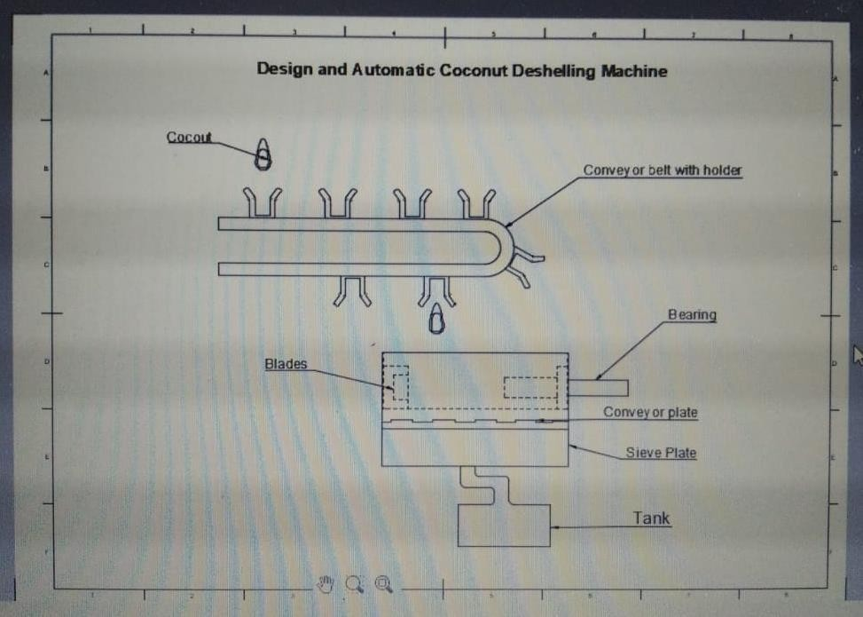

### CONVEYOR BELT WITH HOLDER

Coconut Conveyor Machine Description: This coconut conveyor machine belt is manufactured of stainless steel 304 which is ideal for food processing. Conveyor belt can be horizontal conveyor belt, lifting conveyor belt and surfing conveyor belt.

### Features:

Easy for cleaning; with conveying speed.

### SPECIFICATION

|  |  |
| --- | --- |
| Capacity | 1 ton / hrs |
| Total power | 3kw |
| Material | SUS304 |
| Machine size (L*W*H) | 2000*500*500mm |

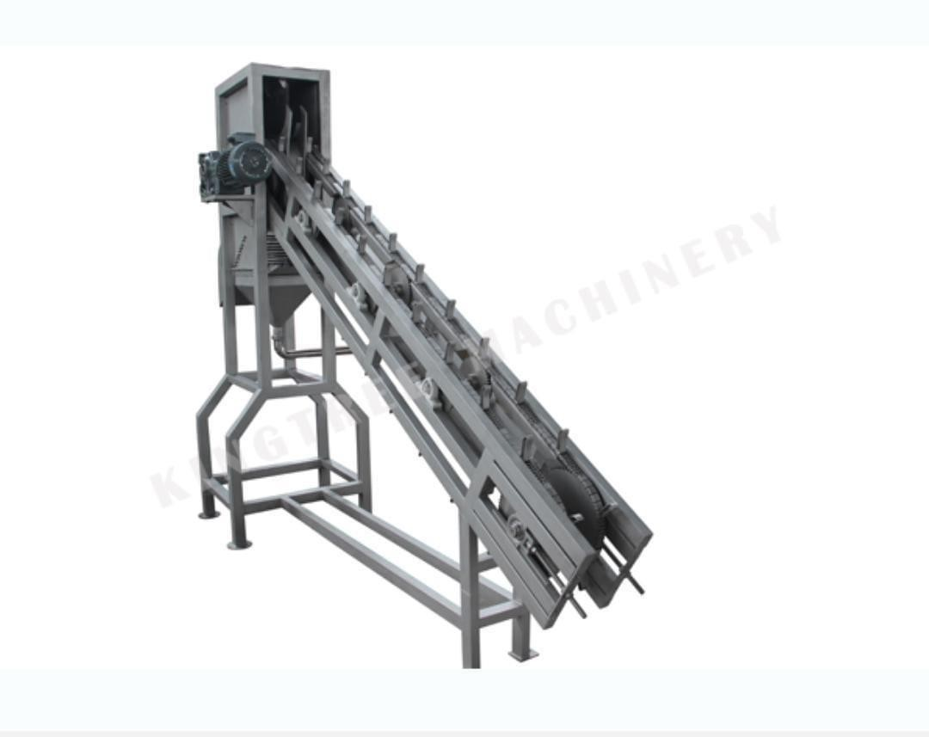

**CROSS CUTTER (BLADE)**

Coconut Conveyor Machine Description: This coconut conveyor machine belt is manufactured of stainless steel 304 which is ideal for food processing. Conveyor belt can be horizontal conveyor belt, lifting conveyor belt and surfing conveyor belt. Features: easy for cleaning; with conveying speed.

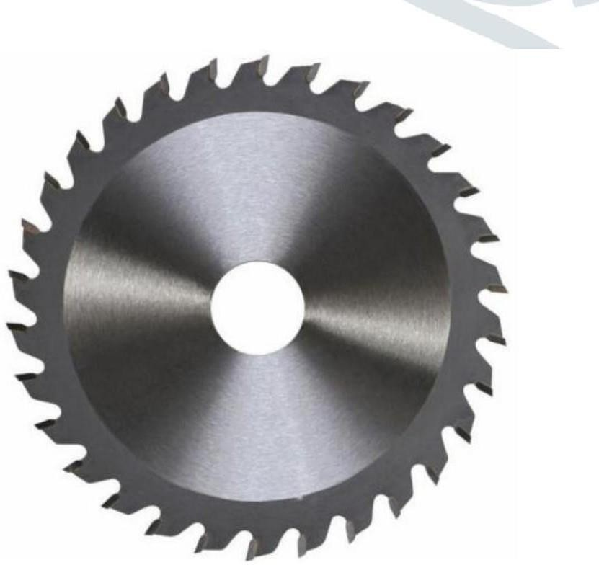

### ELECTRIC MOTOR

An electric motor is an electric machine that converts electrical energy into mechanical energy. In normal motoring mode, most electric motors operate through the interaction between an electric motor's magnetic field and winding currents to generate force within the motor. In certain applications, such as in the transportation industry with traction motors, electric motors can operate in both motoring and generating or braking modes to also produce electrical energy from mechanical energy. Found in applications as diverse as industrial fans, blowers and pumps, machine tools, household appliances, power tools, and disk drives, electric

motors can be powered by direct current (DC) sources, such as from batteries, motor vehicles or rectifiers, or by drives, electric motors can be powered by direct current (DC) sources, such as from batteries, motor vehicles or rectifiers, or by watches. General-purpose motors with highly standardized dimensions and characteristics provide convenient mechanical power for industrial use.

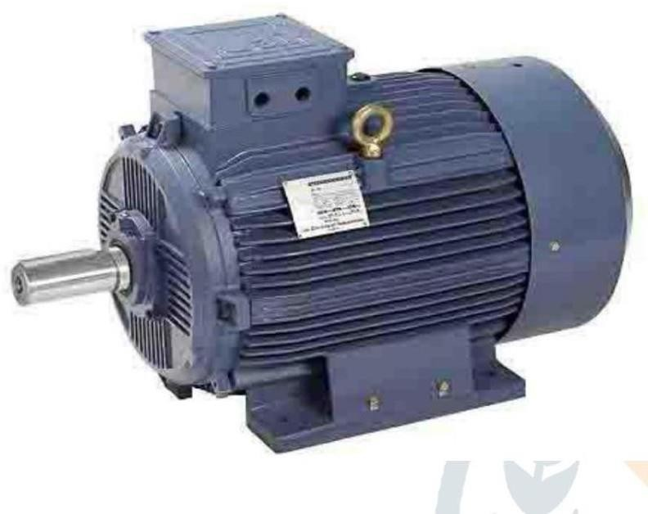

### CHAPTER - 4

### PROJECT DESCRIPTION

1. **Project objectives**:

Our specific goals for this project are:

* + To reduce the labor time required for coconut deshelling by at least 50%.
  + To increase productivity and output by enabling the deshelling of a larger quantity of coconuts within a shorter timeframe.
  + To improve worker safety by minimizing manual labor and potential hazards associated with traditional deshelling methods.

To develop a user-friendly, cost-effective and reliable automated coconut de- sheller machine that is suitable for small-scale coconut farmers.

### Project plan:

1. Research and Design:
   * Conduct an in-depth analysis of existing coconut deshelling methods.
   * Collaborate with experts in engineering and automation to design a machine that meets industry requirements.
2. Prototyping and Testing:
   * Build a functional prototype of the automated coconut de-sheller machine.
   * Test the prototype with a diverse range of coconut types and sizes to ensure its efficiency and reliability.
3. Refinement and Optimization:
   * Incorporate feedback from testing phase to improve the machine's performance.
   * Optimize the machine's design and functionality to ensure seamless integration into existing coconut processing systems.
4. Production and Scaling:
   * Manufacture the automated coconut de-sheller machine for commercial use.
   * Collaborate with coconut processing plants to deploy the machines and gather performance feedback.

### Specifications:

1. Design and Development:

We will collaborate with experts in mechanical engineering and automation to design a functional and efficient automated coconut de - sheller machine. Attention will be given to optimizing the machine's performance, minimizing damage to the coconut meat, and ensuring ease of use and maintenance.

1. High Speed and Capacity:

The machine will be capable of processing a significant number of coconuts per hour, ensuring increased production throughput. By achieving a high-speed operation, we aim to enhance the overall efficiency and productivity of coconut processing facilities.

1. Quality Control:

The automated de-sheller machine will incorporate quality control measures to ensure consistent output. Precise mechanisms will be implemented to remove shells without damaging the coconut meat or introducing impurities. The machine will be equipped with sensors

and software algorithms to detect any variations in coconut quality and adjust the deshelling process accordingly.

1. Safety Features:

Safety is of utmost importance in any industrial operation. Therefore, the de-sheller machine will be designed with multiple safety features, such as emergency stop buttons, protective enclosures, and sensors to prevent accidental injuries to operators.

1. Adaptability and Versatility:

The de-sheller machine will be adaptable to various coconut sizes and types, accommodating the wide range of coconuts found in different regions. Its versatility will ensure widespread applicability and market acceptance.

1. Enhanced Efficiency:

The automated coconut de-sheller machine will significantly increase the deshelling speed compared to manual methods. It will aim to process a minimum of 500 coconuts per hour, which will lead to increased productivity and reduced operational costs for coconut processing companies.

1. Improved Quality Control:

The machine will be designed to ensure consistent and uniform deshelling of coconuts, reducing the risk of damage or contamination. This will guarantee a higher quality coconut meat for further processing, such as coconut oil extraction or coconut water bottling.

1. Cost-Effective Solution:

The automated de-sheller machine will be designed with cost- efficiency in mind. By optimizing the use of materials, streamlining the manufacturing process, and considering maintenance requirements, the machine will provide long-term economical benefits for coconut processing businesses.

1. Safety and Ease of Use:

The design will prioritize the safety of operators and minimize any potential hazards associated with operating the machine. It will also be user-friendly, ensuring that operators can easily understand and manage the machine's functionality.

1. Timeline and Budget:

The project will be divided into specific phases, each with its own deliverables and milestones. The estimated timeline for completion is

3 months, allowing for thorough design iterations, prototype development, testing, and final manufacturing.

### PROBLEM STATEMENT

The coconut is one of the main sources of oil products. In order to obtain the oil from the coconut, there are number of process to be done. The processes are coconut plucking, de-husking, breaking shell, drying, deshelling the kernel from the shell and finally extracting the oil from the kernel. In the above process, the time consuming is the coconut de-shelling, since it is done by using manual labors. Most of the regions use manual de-shelling at present. The coconut is de-shelled by means of using knifes, hooks, etc. Due to manual process, time is consumed, other major disadvantage is the labour problem and by using the external devices there may be a chance of accidents takes place. In order to avoid such kind of difficulties we go for the machining process

* Traditional coconut de-shelling process is time consuming.
* These are laborious, time consuming, cost intensive and involve various processing activity.
* In local methods hygienic conditions are not maintained.

### OBJECTIVES

The coconut de-shelling is one of the most difficult post harvesting operation. In India coconut is cultivated on a large scale. To process such a large number of production of coconuts some suitable mechanism needs to be identified or developed. Several attempts have been made to mechanize the de-husking of coconut. Some of them were manually operated and others were power operated. These mechanisms have their own advantages and limitations. Few of them required skill worker.

Some of them were bulky, time consuming, power consuming, uneconomical.

There is a need to develop some machines in which would work satisfactory and must be economical. Depending upon the necessity the suitable mechanism needs to be selected. Coconut production plays an important role in the national economy of India. Coconuts are known for its versatility as seen in many uses of its different parts.

It also has cultural and religious significance in many societies. Copra is the dried meat or kernel of the coconut. Traditionally coconut shell is operated manually to get copra out. But it consumes more time and more Physical Exertion of workers, so the main objective is to reduce time consumption and Physical Exertion by introducing a machine to break coconut shell.

It should be to operate with less wastage of copra. This machine reduces the accidents that may happen during de-shelling manually. The present work involved the design, development and testing of a coconut de-sheller which overcomes the drawbacks of the previously reported implements. The design and developmental stages called for a closer look at the magnitude and direction of the de-husking forces and their generation mechanisms.

Details of a simple, sturdy and efficient hydraulic de-sheller unit, financially beneficial to laborers and producers, are given here.. Cost benefit analysis indicates that it should be commercially viable. Main purpose of manufacturing coconut de-husker is to reduce the human effort and increasing efficiency.

### KEY OBJECTIVE

* To reduce human effort.
* To increase continuous work capacity.
* To increase efficiency than conventional system.
* Less harmful to user.

### CONCLUSION

In order to get around the drawbacks and issues with the current machinery, the study describes the design and development of an automatic coconut deshelling machine. The novel design shears the coconut husk from the coconut using two horizontal rollers equipped with sharp tools, increasing operator safety and automation. The machine includes a manual loading and unloading mechanism and can deshell fruits without breaking the nuts. An estimated Rs. 6250 is needed to produce one unit of the equipment. Furthermore, the device removes the need for rural communities to rely on unreliable public power supplies, which poses a significant challenge for current automated coconut deshelling machinery. In general, the machine outperforms traditional methods in terms of production rate**.**

### LITERATURE REVIEW

**TITLE : “DESIGN OF AUTOMATED COCONUT DESHELLER”**

T.Vidhan Singh and R. Udhayakumar [1] this literature gives a view to develop a power operated coconut de-shelling machine was designed and developed. The capacity of the machine is 200 nuts or 400 cups per batch. The loading and unloading are done manually. The optimum average moisture content for the maximum de-shelling efficiency (92%) was 35% (d.b). The optimum rotating speed of the de-shelling machine was 10 rpm and the time taken for de-shelling was four minutes per batch. The time saved by using the de-shelling machine was four times as compared to the manual method.

Satip Rattanapaskorn and Kiattisak Roonprasang [2] the author has analyzed the feasibility of a design and development of semi-automatic cutting machine for young coconuts. The purpose of this research is to design, fabricate, test, and evaluate the prototype of a semi-automatic young coconut fruit cutting machine. The design concept is that fruit cutting is accomplished by pneumatic press on a young coconut sitting on a sharp knife in a vertical plane. In operation, a young coconut is placed on the cutting base and the pneumatic control is switched on. The coconut is automatically moved to the ressing unit and cut in half by a knife set. The coconut juice flows down to the tank while the cut fruits are separated and moved into the other tank. The machine is found to operate safely without damage to the fruits. The machine capacity is 480 fruits/hr with the total operating cost of about 2.63 USD/1000 fruits.

T. Roshni J. Jippu C. S. Ratheesh, and J. Sachin [3] The author has analyzed the feasibility of a power operated coconut punch-cum-splitter was developed for extracting coconut water and coconut meat. The nut of the screw rod was rotated with an electric motor and the drive was transmitted with a belt and pulley system. The tender coconut was placed on the top of the screw rod in natural rest position and was raised to press against either the punch or the blade fixed above the screw rod. The average energy requirement for punching and splitting of the selected range were found to be 11.74 kJ and 12.13 kJ. An electric motor assisted apparatus was developed to punch and split open the tender coconuts. The force required for punching and splitting was found with a mean value of 712 N and 1277 N, respectively.

J.Bhaskar and V. K. Singh [4] this article focuses on an approach based on the aim of present investigations is to evaluate the physical property-water absorptions and mechanical property-compressive properties. Coconut particle reinforced composites were fabricated by reinforcing shell particle (size between 200-800μm)by wt% of 20, 25, 30 & 35 into epoxy matrix. Composites plates were made by casting in open mould. That is possible with very low cost and easy way. Experimental results showed that water absorption increases with the increase of wt% of particle but compressive properties increase upto 30wt% of particle approaches to actual compressive strength of epoxy.

J.Olumuyiwa Agunsoye and Sanni O. Samuel [5] This paper discusses about mechanical properties of coconut shell reinforced polyethylene composite have been evaluated to establish the possibility of using it as a new material for engineering applications.

The result shows that the hardness of the composite increases with increase in coconut shell content though the tensile strength, modulus of elasticity, impact energy and ductility of the composite decreases with increase in the particle content. Scanning Electron Microscopy (SEM) of the composites (with 0% - 25% particles) surfaces indicates poor interfacial interaction between the coconut shell particle and the low density.

Vijay Kumar G. Tile et.al***.****:*In this Research paper author says that India is one of the most coconuts growing country in the world. For the effective utilization de-shelling is essential. De-shelling is the process of expelling husk from the coconut. The conventional methods are foot operated de-shelling machine, mechanical coconut de-shelling machine and hydraulic operated coconut de-husking machine. As the hydraulic operated machine has high cost, another machine is presented. This machine is operated by using pneumatic systems. Valve is introduced to guide the direction for flow of fluid and dedicated lever mechanism to give downward motion of the tool. Tool having blades which penetrate into the husk and detach it without breaking the nut. Due to use of pneumatic system this machine reduced the requirement of skilled labour and time consumption.

Vishnu Murli, et.al.:In this paper author says that coconut water used as a healthiest drink which is naturally available. In many countries like it is obtained by splitting and punching but this is risky. That’s why the proposed model consists of hydraulic system and frame with fixture which hold the coconut. Piercing operation is done with the tool which is operated by hydraulic system. The lever is used to control the motion of the tool. The DCV is controlled by user, tool used is hollow steel pipe which penetrate the coconut and extract the water. With this piercing operation water is extracted which maintained the hygiene of water and increase productivity. Due to the use of hydraulic system, it reduced  the time consumption for the water extraction  process.

Mohd Fauzi Mohd Yunus, et.al. *:*In this paper author given that this paper consists the development conceptual design for dual purpose coconut processing  machine. Prototype of the machine is created and tested which used to obtained de-husked as well as grated coconut. Which operated at different speed for both the operations. Three conceptual designed machines are analysed where two persons are performing two different operations simultaneously to because tools are situated adjacently. The de-husking is carried out repeatedly until the complete husk is removed.     Results obtained from this testing on prototypes a final conceptual design is proposed for performing both the de-husking and grating operation efficiently.

Krishnan.R et.al : In this paper author found that the coconut is used by one third peoples of our world. But for the utilization it  needs to de-husked before it,  manual methods for de-husking are time consuming and it has risk of injury. It requires mechanized system but the existing technology consists hydraulic systems which is not affordable for the producer. To overcome these problems  proposed system has simple mechanism having motorized shaft with spikes which penetrate into  the husk and remove it. Gear box reduces speed from 960 rpm to 30 rpm of shafts to penetrate spikes in to the nut and peel off them. Gear box and connected with motor shaft which is lie on the same line to reduce the vibration and proper utilization of power to increase productivity.

Danny Thomas, et.al. : In this research paper author analysed that India is the third largest producer of coconut in the world and it accounts 50% of coir trade across the world. Coir is the outer cover of the coconut which is also called as husk. To remove the husk manually by labour and mechanized machine which requires skilled labour. To reduce the requirement of skilled worker to de-husk the coconut development and design of Automated coconut de-husking machine. This machine consists two rollers having spines mounted on frame, and powered with sprocket driven by chain drive. Motor is used with worm and worm gear assembly to drive chain drive. The experiments is done on the both the mature and immature coconut to determine the force to de-husk the coconut. Due to its simple design operation of machine is simple and having less maintenance with high efficiency. Due to automation it eliminates the labour required for this operation and increase productivity.

Nwankwojike et.al.:In this paper author analyzed that the coconut is one of the world’s most useful and important plant. Outer cover of the coconut is called as husk. There are various uses of coconut like coir in coir carpet, coir composites etc. Coconut water as a refreshing drink, it`s  oil is also used in cooking foods and shell as fuel source. As the coconut has economical and industrial importance removal of husk is the important task. The existing methods are manual and mechanized such as machete which having some limitations. To overcome these limitations a new de-husking machine is introduced, consists of two cylindrical rollers with spikes and screw conveyor is fixed in between to rollers. Screw conveyer was used for effective twisting and discharging of nut after de-husking. This machine de-husk nuts without breakage and distortion. Which performs with the efficiency and capacity of 93.45% and 79 nuts per hour. This machine eliminates the problem of extracted coir fiber length and reduce the risk and hazards of manual de-husking machine.

Yohanes Nusbir, et.al:In this research paper author says that Indonesia is the second largest producer of coconut and it has greater economic importance. Husk obtained from coconut used as a raw material for the production of various products like carpets, car seats, etc. But the manual methods for de-husking with tools like crowbar may injures the workers. To defeat these problems several research is carried out in this field and few automated  machines was created. These machines having some complexity in de-husking due to which an innovative machine has been designed by Quality Function Deployment (QFD). Which based on coconut farmer's community requirements to determine the parameters of design. A survey to identify population and sample, choosing survey method, design questionnaire and distribute the questioner were done to collect coconut farmer's community needs. Afterwards Home of Quality (HOQ) is introduced to design to meets the requirements. The finalize machine consists of rollers with conical sharp knife, and 3HP motor of 2700 rpm speed, and reduction ratio of 1.50. This machine operates with low maintenance, low in cost and quickly in the de-husking.

S.D.S. Piyathisa et.al.: In this paper author says that the most of the parts of coconut fruits are used in industries as coconut oil products, coir products, shell products and copra. Coconut has outer fruit coat called exocarp, which protect the edible flesh. For utilization in industries, it should be de-husk. The prevailing methods are laborious and time consuming and semi-automatic and automatic machines are not affordable for the small-scale farmers. Due to several research is carried on de-husking    and a manual system is introduced with appropriate mechanical way for coconut de-husking. The most of the methodologies which consists of rollers with spike makes it laborious, dangerous and expensive. To overcome this problem proposed system has liver operated tool supported by frame. Tool having arm like structure with sharp blades which penetrate the fruit. Due to the movement of lever arms moves outwards and detach the husk from nut.  It is more efficient, affordable and require less force about 50 kg weight only.

Ovat, Friday Aje et.al.:     In this research paper author given that it consists the development and performance evaluation of coconut de-husking machine. Although coconut has immense economic importance in industries and rural residents. But it is difficult and dangerous to de-husk with the manual methodology. Proposed system is motorized which use rollers with spikes and which penetrate the fruit and remove the husk. The plurality in spikes and inside motion of rollers causes effective gripping on the husk. Gradually tapered arrangement of rollers improves the efficiency of de-husking machine. Modification and improvement of an existing coconut de-husking machine for farmers was carried out and evaluated. The performance evaluation shows that the efficiency of the machine was 92.50% while the average capacity was 120.6 coconuts per hour. Whereas the percentage number of distorted and broken coconuts were 7.5% and 3.75%. These figures are less in compare to the existing coconut de-husking machine.

J. B. Alcantra, et.al.:In this research paperAuthor says that the current manual de-husking are tedious and time consuming. Due to this an automated coconut de-husking and Cutting Machine was presented and developed. This machine uses pneumatic systems for actuation in machine and electronic control system for control the operations of pneumatic system. By using these systems an efficient automated machine was created. De-husking process starts with entering of coconut inside the de-husking section which consists of spiked rollers. After proper de-husking nut transferred towards the cutting section having pneumatic clamp with cutting which de-shell the nut. By using this automated machine 5 nuts per minute can be de-husked and de-shelling without any injury to machine the operator.

N. Senthilnathan, et.al.*:*In this research paper author analyzed thatmade a study on the traditional Pedal operated and Hand operated de-huskers and concluded that  De-husking efficiency of motorized system is more than 90% based on the calculations made on the total weight of the husk removed from the coconut and stated that the electric operating systems are faster and more efficient than conventional de-husking tools. The conventional tools and proposed system had spiked rollers powered by a motor to de-husk the coconut. The motor used for de-husking was 3 phase, 5 HP motor. Due to which this de-husking machine having good efficiency and it is more economic compare with others.

R. NAVNEETHAN et.al. In this research paper Author said that, Coconut is a primary yield of konkan district.  De-husking of coconut is essential process in preparing the coconut for effective usage. Coconut de-husking includes expelling of husk from the coconut fruit. Coconuts are de-husked manually using tools like crowbar and machete. These processes are tedious and time consuming which causes injury to the operator. These methods required skilled labor for de-husking and lack of concentration may hazards sometimes. To beat these restrictions, to improve efficiency motorized machines are introduced some of which are semiautomatic and automatic. But these machines are not affordable for the small-scale industries and farmers. Another structure of de-husking machine is designed and manufactured. Parallel roller shafts are fixed on the frame which having spikes coupled by with the gear arrangements. The rollers are supported by the bearing rotated in opposite direction which de-husk the coconuts. This de-husking machine powered by the 1.5-2 HP motor of the 1440 rpm.

K. Ramadurai et.al. : As Per the Author it is found that in daily life the coconut is one of the most use full and important Plants. Coconuts Provides food, edible oil, Industrial products and health drink. To de-husk the coconut development and design of machine is carried out which consists of two rollers with spikes. The machine is motorized by ac motor transferred power through belt and pulleys which reduce the rpm of rollers.  Efficiency of machine increased by reducing idler time. Automation of machine eliminate the requirement of skilled labor.

### RESULT

**REFERENCE**

1. Coconut Machines, [www.coconutmachine.com/index.php?mid=72,](http://www.coconutmachine.com/index.php?mid=72) Retrieved on Jan. 15, 2014.
2. Coir Machines, Coir Fiber Extraction Machinery, <http://www.coirmachines.net/coir-fibre-extraction> machinery. html, Retrieved on Jan. 15, 2014.
3. Debkumar Chakrabarthi, India Anthropometric Dimensions, NID, Ahmedabad: National Institute of Design, pp100, 1997.
4. Chandra Dinanath. “Coconut dehusking machine”. U.S. Patent 4708056A, Nov. 24, 1987.
5. Luise Cancel, San Juan, Puerto Rico. “Coconut Breaking Machine”. U.S Patent 3,605,834, Sept. 20, 1971. 6. Albert L Mix, Battle Creek, Mich. “Coconut Shelling Machine”. U.S Patent 2,783,801, Mar. 5, 1957.
6. Genaro Celaya. “Machine for Husking Coconuts”. U.S Patent 1,781,215, Nov. 11, 1930. [5] Ohler, J.G. Coconut, Tree of Life. FAO Plant Production and Protection Paper 57. FAO, Rome, Italy, 1984.
7. APCC. Coconut Food Process – Coconut Processing Technology.

Information Document. Arancon, Jr, R.N, ed. Asian and Pacific Coconut Community. Jakarta Indonesia, 1996.

1. Franco, P.J.H. and Gonzalez, A.V. Mechanical Properties of Continuous Natural Fiber - Reinforced Polymer Composites. Comp. Part A: App. Sci. Manuf., Vol. 35, pp. 339-345, 2004.
2. Balzer, P.S., Vicente, L.L., Briesemeister, R., Becker, D., Sordi, V., Rodold, A. Jr and Feltran, M.B Study of Mechanical Properties of PVC/ Banana. Journal of Emerging Trends in Engineering and Applied Sciences (JETEAS) 2(2):231-234, 2007.
3. Tilledaratne, H.A. Processing of Coconut Products in Sri Lanka Asian and Pacific Coconut Information Document. Arancon, Jr., R.N., ed. Asian and Pacific Coconut Community. Jakarta, Indonesia. 1995.
4. Sharma, P.C. and Aggarwal, D.K. Machine Design. S.K. Kataria and Sons, Nai Sarak Dechi. Katra [books@yahoo.com,](mailto:books@yahoo.com) 2006.
5. Khurmi R Sand Gupta, J.K., A Textbook of Machine Design (SI Units), Eurasia publishing House (PVT) Ltd., Ram Nagar, New Delhi - 1105s, 2005.
6. IS 2494 - 1974. Indian Standards. Indian Standards Institute, New Delhi, 1974.
7. Rajput, R.K. Strength of Materials, S. Chand & Company Ltd, Ram Nagar, New Delhi, 2006.
8. PCA-CETC. Coconut Processing Technology Manual of Procedures Coconut Extension Training Centre, Davao City, Philippines, 1997.